AWS GenAI POC
Motadata
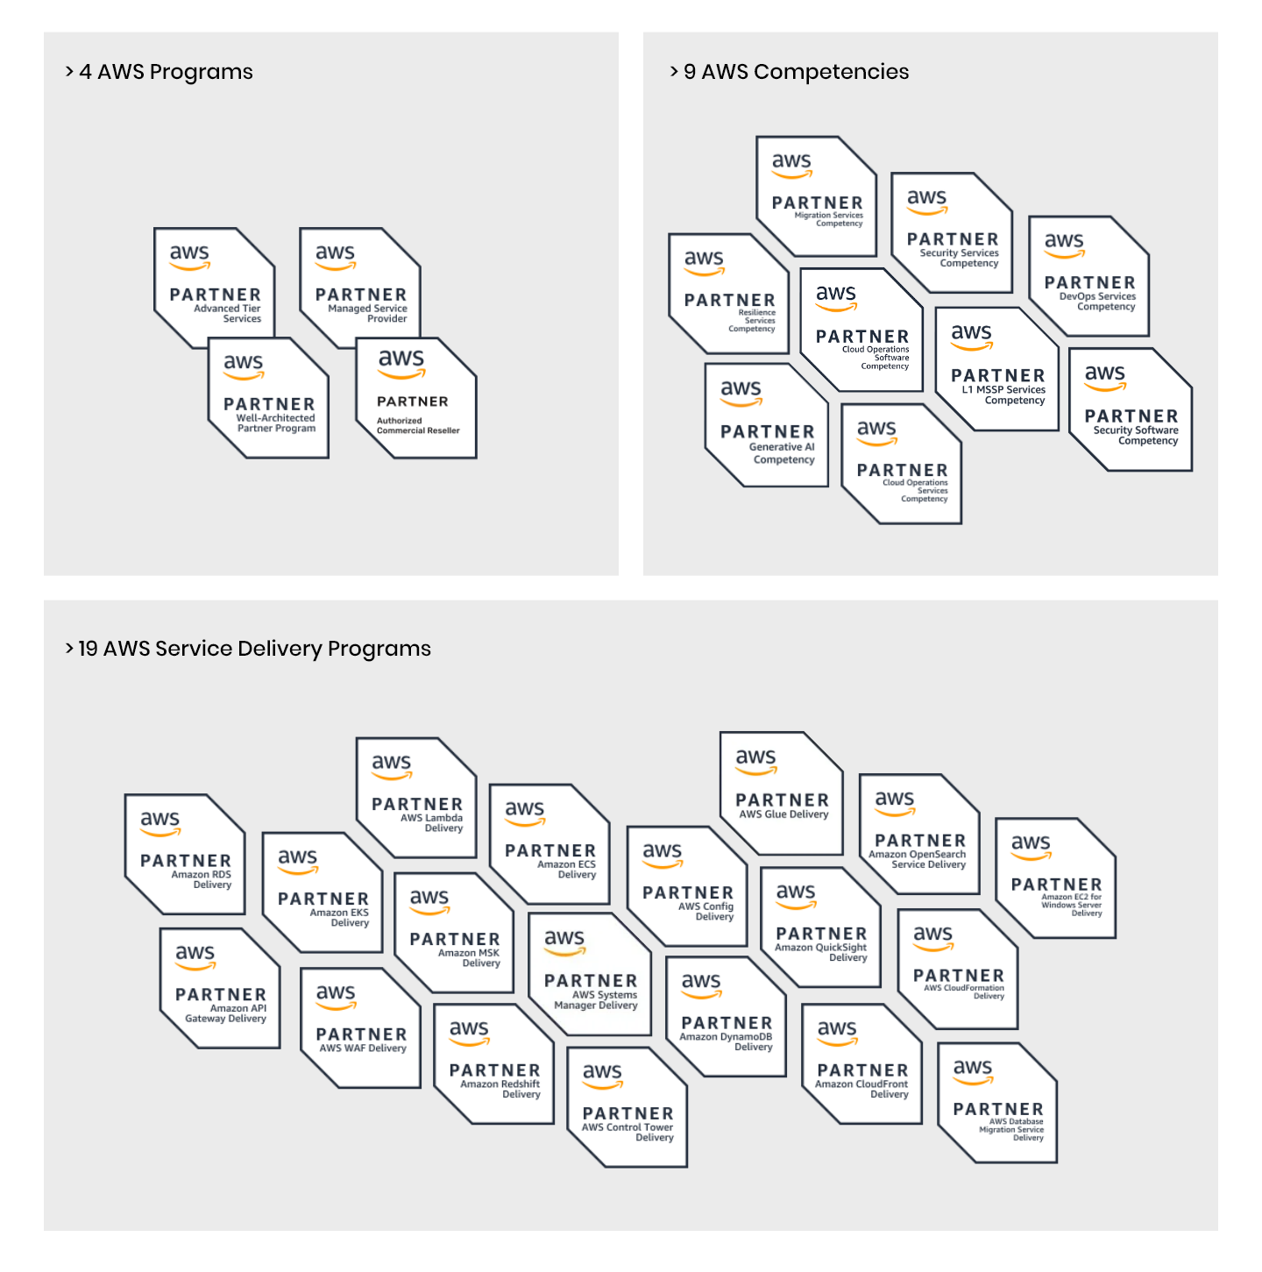
Revision History

Version | Date | Description | Author | Reviewer
v1.0 | 12-08-2026 | Initial Draft | Vynkatesh Sinhasane | Aditya Kapole
v2.0 | 22-07-2026 | Updated the description of the investigator agent in the document. | Vynkatesh Sinhasane | Aditya Kapole
v3.0 | 06-08-2026 | Updated about the RDS PostgreSQL Setup | Vynkatesh Sinhasane | Aditya Kapole

Table of Contents

Introduction 4
Overview of the Setup 4
ECS Cluster Setup 5
Amazon Bedrock AgentCore Setup 9
S3 Bucket Setup 13
RDS PostgreSQL Setup 14
CloudFront and Cognito Setup 16
Code Change and Deployment Process 17
Tenant Account Management 21

Introduction
This Knowledge Transfer (KT) document is a comprehensive guide for understanding and managing the AWS infrastructure setup for the Motadata AI-Powered RCA Agent. It aims to provide detailed insights into the various AWS services and configurations used in the deployment. The document is designed to empower team members, administrators, and relevant stakeholders with the knowledge to operate and maintain the deployed infrastructure effectively.

Overview of the Setup
The Motadata GenAI Proof of Concept (POC) implements a containerized, cloud-native multi-agent AI architecture deployed on AWS using Amazon Bedrock AgentCore and LangGraph. The system is designed to support automated Root Cause Analysis by correlating telemetry data across metrics, logs, and traces through a natural language chat interface.
The solution exposes a secure web interface through Amazon CloudFront backed by AWS WAF. API requests are routed to an ECS Fargate service running the FastAPI backend, which acts as a thin orchestration layer handling authentication, session management, and delegation to AI agents. Static frontend assets are served from an S3 origin bucket.
The AI layer runs entirely on Amazon Bedrock AgentCore with a Supervisor agent orchestrating 7 specialist agents via Agent-to-Agent (A2A) protocol. Each specialist handles a specific domain — CloudWatch monitoring, Security Hub findings, Cost Explorer analysis, Trusted Advisor recommendations, Jira ticket management, AWS documentation search, and telemetry-based RCA investigation. Tool access is provided through an AgentCore Gateway with registered MCP (Model Context Protocol) servers.
Multi-tenant isolation is enforced at every layer through Cognito JWT authentication, AgentCore Memory namespacing per user, and STS AssumeRole for per-tenant AWS account access. The RCA Investigator agent queries a tenant-scoped PostgreSQL database containing OpenTelemetry-format telemetry data to perform deep causal analysis with evidence correlation.
The system is deployed in a single AWS account in the ap-south-1 (Mumbai) region, with CloudFront and WAF operating globally from us-east-1.
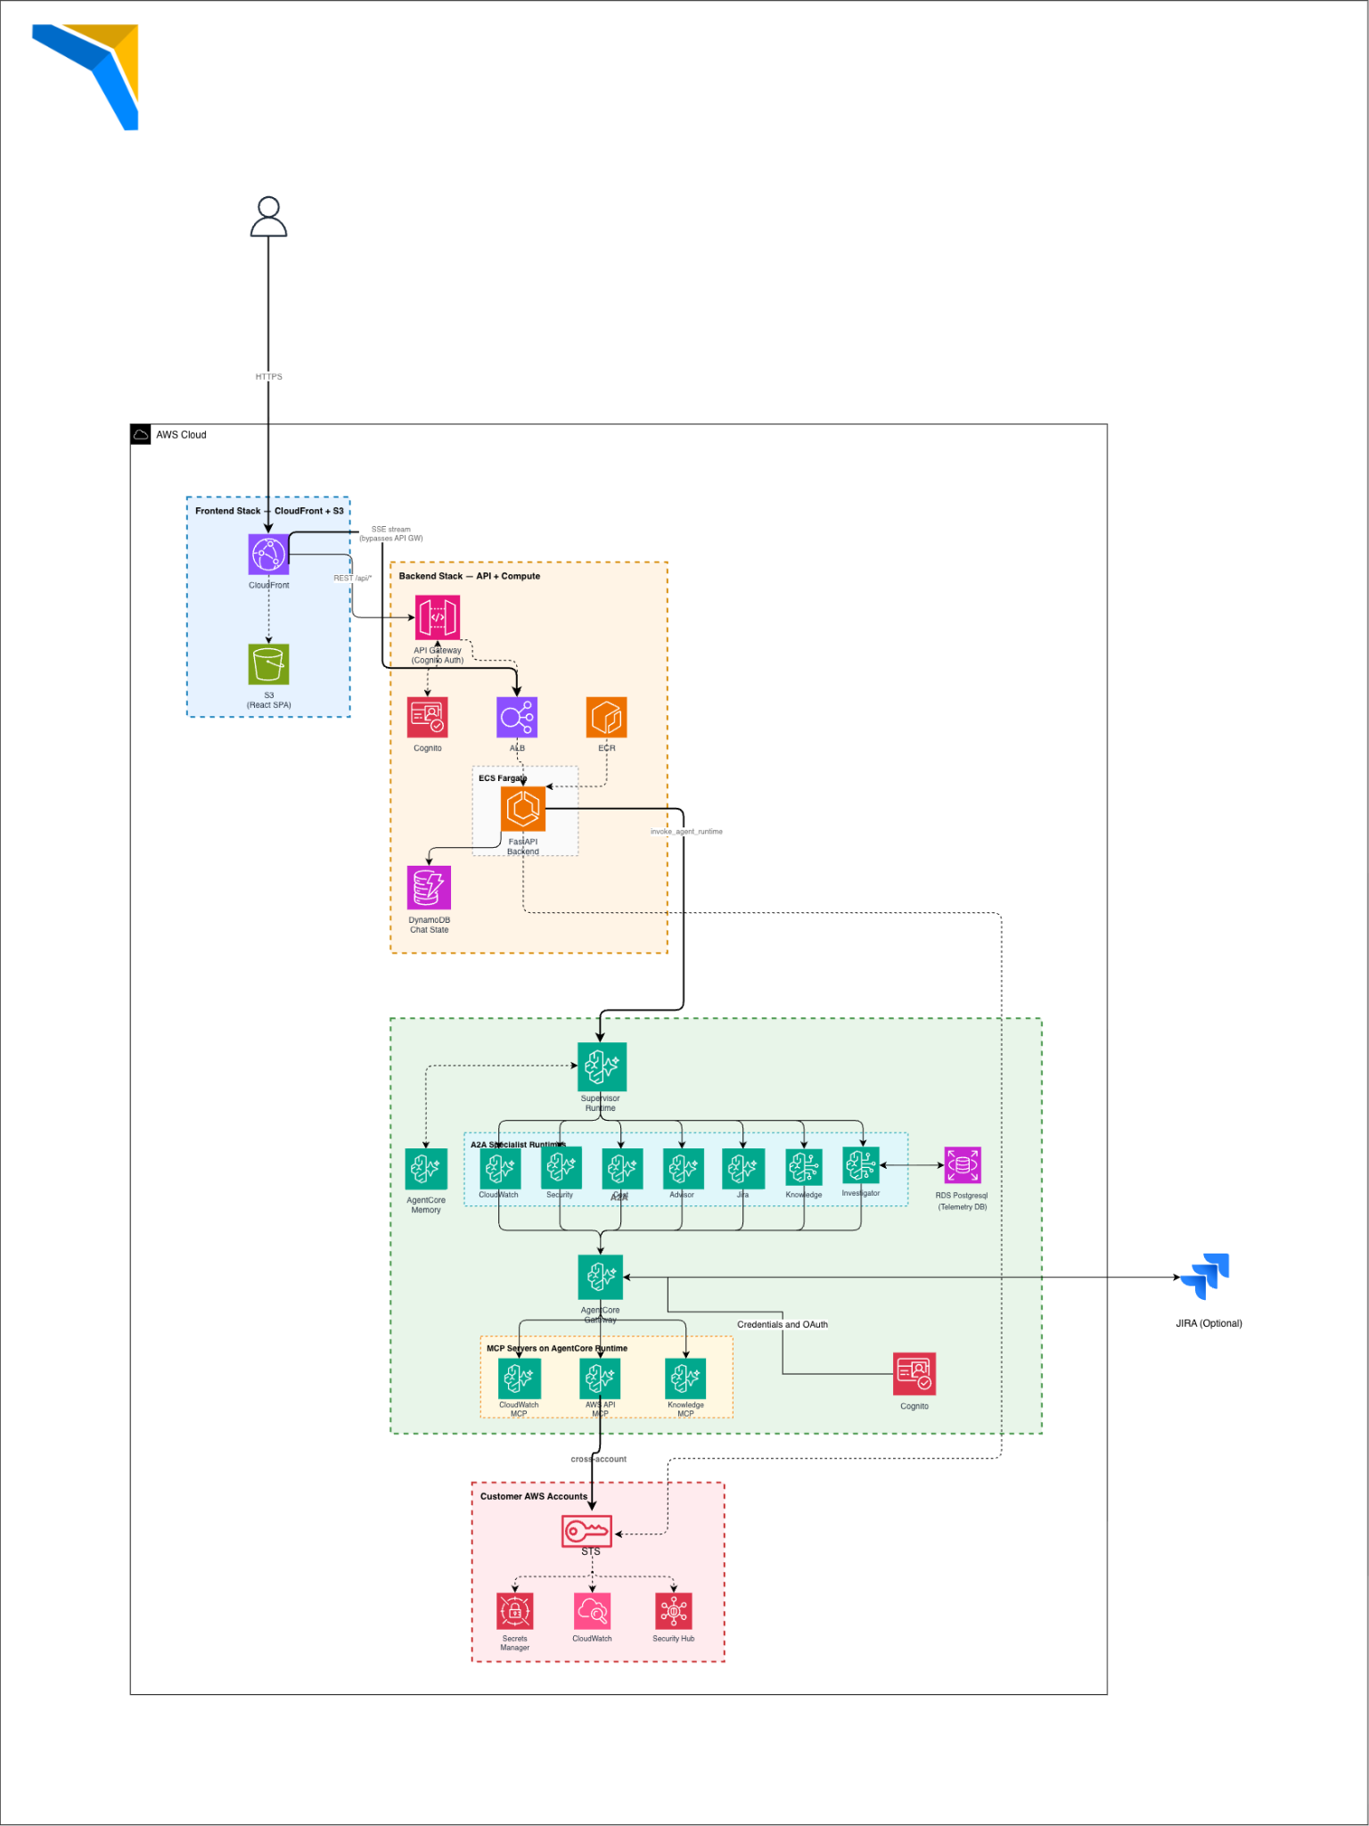

ECS Cluster Setup
The Motadata RCA Agent backend is deployed on Amazon ECS Fargate within the ECS cluster named poc-cluster in the ap-south-1 region. The cluster runs a single ECS service named poc-backend-service with a desired count of 2 Fargate tasks for high availability. Each task runs with 512 CPU units and 1024 MB memory, using the latest revision of the task definition poc-backend-task. The service is deployed in private subnets (subnet-042bf0a08c81d9bc0, subnet-0757cf15768a0a5c0, subnet-0ded7be4062c01f27) within the VPC and configured with auto-scaling based on CPU target tracking (scale-out at 70%, scale-in at 63%).
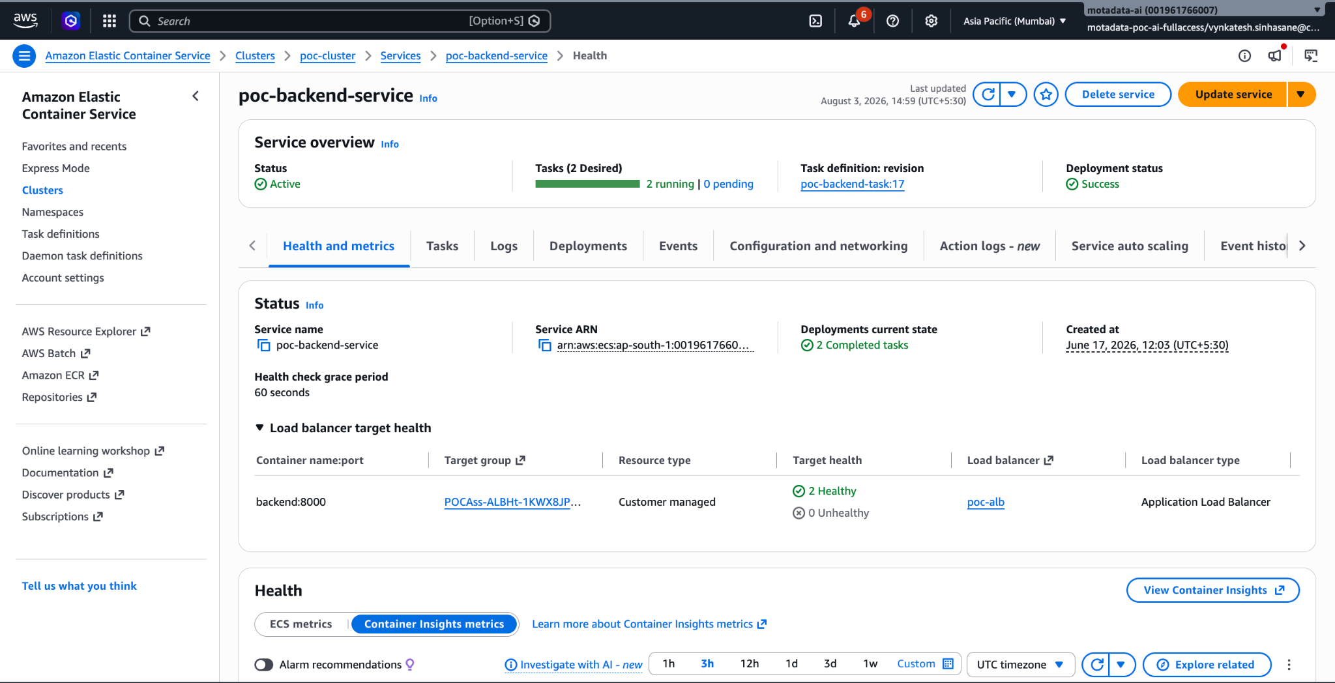

ECR Setup
Container images for the backend application are stored in Amazon Elastic Container Registry (ECR) under a private repository in ap-south-1. The repository 001961766007.dkr.ecr.ap-south-1.amazonaws.com/poc-backend stores the FastAPI application image built from the project's Dockerfile. Updated Docker images are built locally with the linux/amd64 platform flag, tagged, and pushed to this repository. When a new image is pushed, the ECS service is updated with a force-new-deployment command to pull the latest image.


Application Load Balancer (ALB) Setup
Inbound API traffic is managed by an internal Application Load Balancer named poc-alb in the ap-south-1 region. The ALB DNS endpoint is poc-alb-1735024846.ap-south-1.elb.amazonaws.com. It is associated with security group sg-0c795fe63c351e3b3 and forwards traffic to the target group POCAss-ALBHt-1KWX8JPMJTBQ on port 8000.
CloudFront routes all /api/* requests to this ALB as a custom origin with HTTP-only origin protocol (port 80). The ALB performs health checks on the /health endpoint with 30-second intervals and 10-second timeouts. The ALB is placed in private subnets and is not directly accessible from the internet — all external traffic flows through CloudFront.
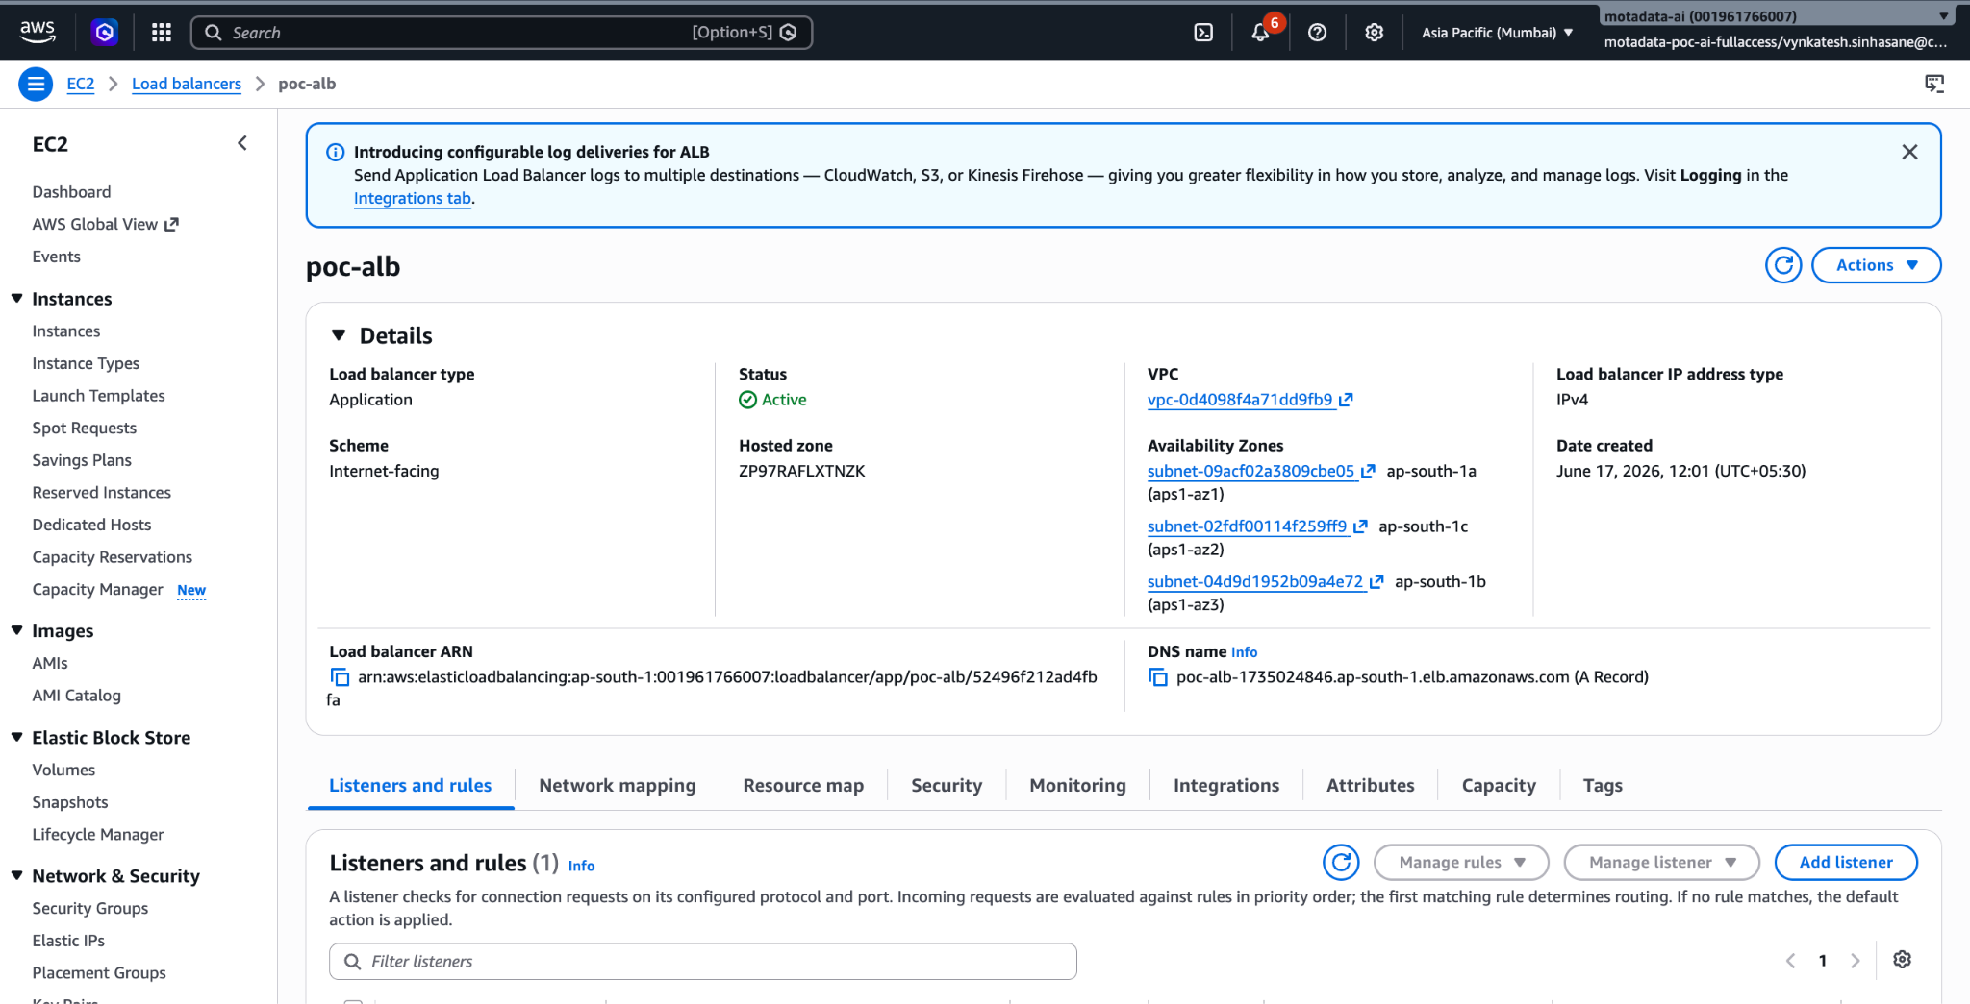

Task Definition Containers

Each ECS task runs three containers:
- Backend :
  - The FastAPI application serves the chat API on port 8000. Built from the project Dockerfile at backend/Dockerfile using Python 3.11 Alpine base.
- Adot-collector :
  - AWS Distro for OpenTelemetry (ADOT) collector (v0.40.0) running as a sidecar. Receives OpenTelemetry traces on ports 4317 (gRPC) and 4318 (HTTP) and forwards them to AWS X-Ray. Configured via the AOT_CONFIG_CONTENT environment variable with a health check extension on port 13133.
Key environment variables configured on the backend container include AWS_REGION (ap-south-1), COGNITO_USER_POOL_ID (ap-south-1_XoMze1ISf), SUPERVISOR_RUNTIME_ARN (the AgentCore supervisor ARN), MEMORY_ID (poc_msp_memory-LxXr4nGE6g), GATEWAY_URL (the MCP gateway endpoint), OTEL_ENABLED (true), and DATABASE_URL (PostgreSQL connection string for the RCA telemetry database).

Amazon Bedrock AgentCore Setup
The agent orchestration layer is deployed entirely on Amazon Bedrock AgentCore, consisting of 11 runtimes, 1 gateway, and 1 memory resource. All runtimes are managed via the AgentCore CLI from the CDK project located at agentcore-deploy/motadatamsp/.
Runtimes :
The system deploys 11 AgentCore Runtimes — 1 Supervisor, 7 specialist A2A agents, and 3 MCP tool servers. All runtimes use networkMode: PUBLIC with HTTP protocol on port 8080, and each has enableOtel: true for observability.
- Supervisor Runtime
  - (motadatamsp_supervisor_langgraph-9KnVEoGxwe) is the entry point for all user queries. It runs a LangGraph create_react_agent with Claude Sonnet 4.5 (global.anthropic.claude-sonnet-4-5-20250929-v1:0) and has 7 delegation tools that invoke specialist agents via A2A protocol. The supervisor loads conversation memory, classifies intent using an SRE-methodology prompt, and routes to the appropriate specialist.
- CloudWatch Agent (motadatamsp_cloudwatch_a2a-H5RcGb9DcS) queries live CloudWatch alarms, metrics, and log groups for the selected tenant's AWS account using STS temporary credentials read from Secrets Manager.
- Security Agent (motadatamsp_security_a2a-IXIDFxBpup) retrieves Security Hub findings, CVEs, and compliance status from the tenant's account using the same STS credential injection pattern.
- Cost Agent : (motadatamsp_cost_a2a-wzbLX73tnc) queries AWS Cost Explorer for spending patterns and optimization opportunities.
- Advisor Agent : (motadatamsp_advisor_a2a-rLgT026HbV) retrieves Trusted Advisor recommendations across cost, security, performance, and fault tolerance pillars.
- Jira Agent : (motadatamsp_jira_a2a-F9Z6ao4iK8) manages Jira tickets — creating, querying, and updating issues for incident tracking.
- Knowledge Agent : (motadatamsp_knowledge_a2a-HH7Is0DX6i) searches AWS documentation and best practices to support investigation recommendations.
- Investigator Agent : (motadatamsp_investigator_a2a-ihVlFH4B57) is the core RCA engine. It connects to a PostgreSQL telemetry database using LangChain's SQLDatabaseToolkit and performs multi-step SQL-based investigation across otel_metrics, otel_logs, and otel_spans tables with a recursion limit of 30. It uses Claude Haiku 4.5 and filters all queries by tenant_id for multi-tenant isolation.
- MCP Servers : (CloudWatch MCP, AWS API MCP, AWS Knowledge MCP) provide tool access through the AgentCore Gateway using SigV4 + OAuth authentication.
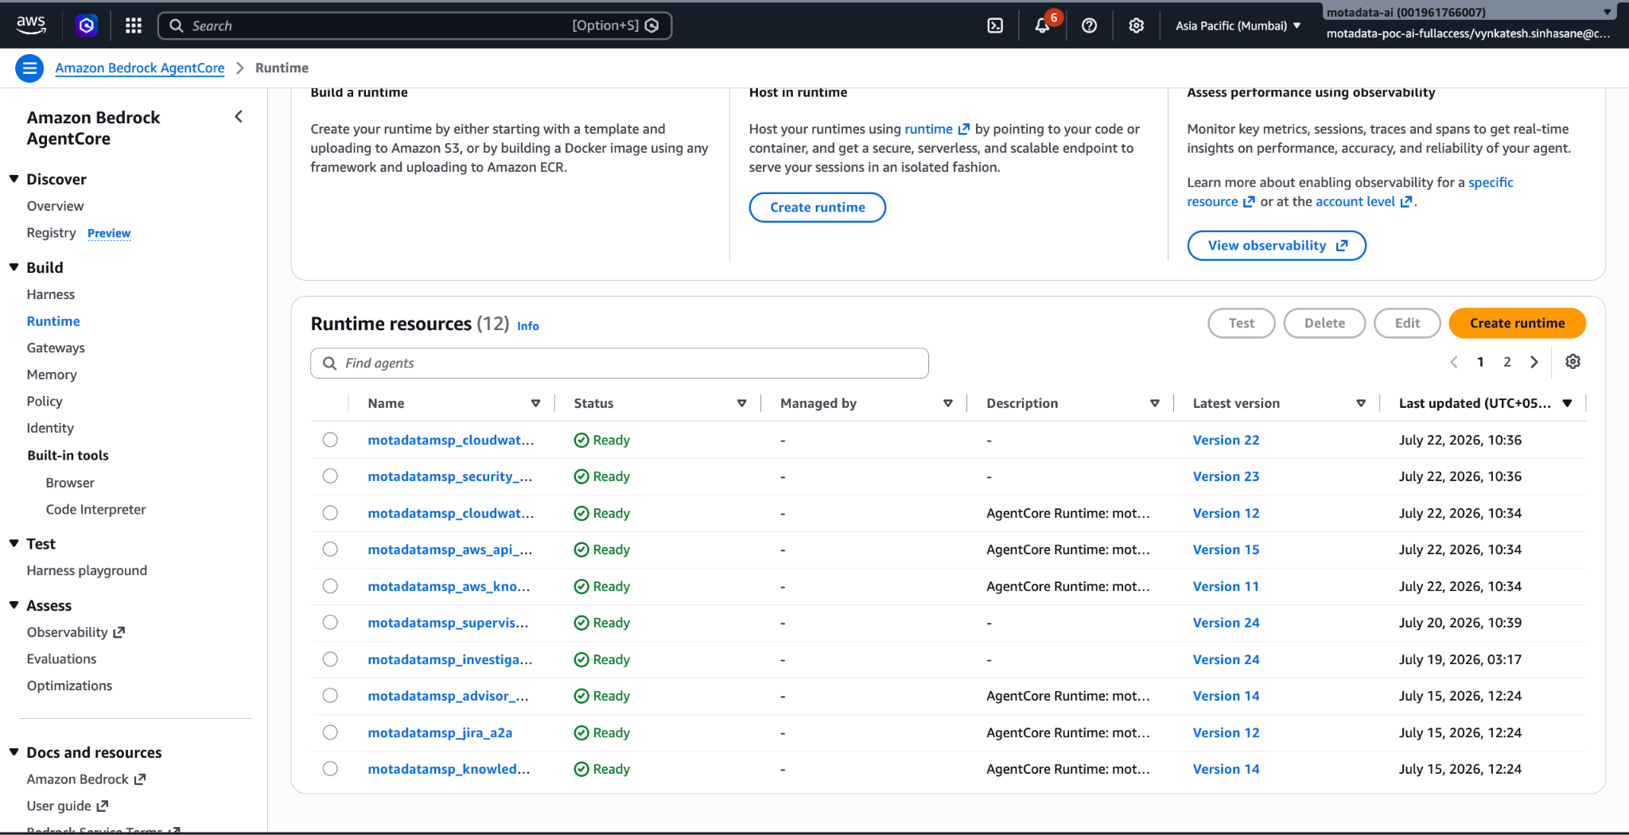

Gateway

The AgentCore Gateway named msp-assistant-gateway-hygxaasfuh provides a unified MCP endpoint for tool access. It has 3 registered targets: the CloudWatch MCP server (providing CloudWatch Logs, Metrics, and Alarms tools), the AWS API MCP server (providing general AWS API access), and the AWS Knowledge MCP server (providing documentation search). Specialist agents connect to the gateway via SigV4-signed requests at the endpoint https://msp-assistant-gateway-hygxaasfuh.gateway.bedrock-agentcore.ap-south-1.amazonaws.com/mcp.
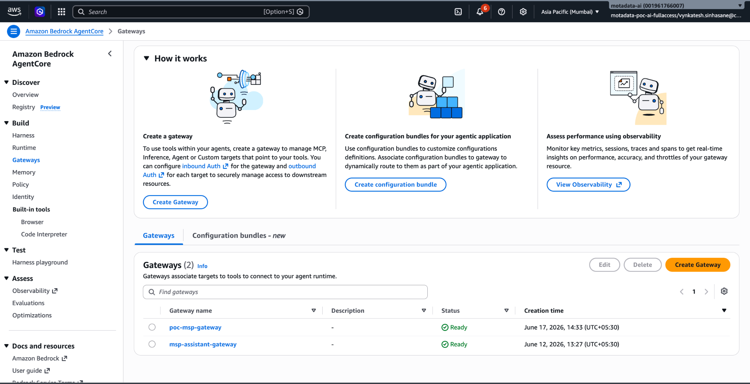

Memory
AgentCore Memory resource poc_msp_memory-LxXr4nGE6g provides conversational persistence with two extraction strategies configured:
- SemanticFacts :
  - Extracts factual statements from conversations (e.g., "The user's production account is 123456789") and stores them as retrievable semantic facts that persist across sessions.
- SessionSummaries :
  - Generates concise summaries of completed sessions capturing key topics, decisions, and actions taken.
Memory is namespaced by actorId (derived from the Cognito user's sub claim), ensuring complete isolation between users. The namespace pattern is /strategy/{strategy_id}/actor/{actorId}/.
Foundation Models

Agent | Model | Purpose
Supervisor Agent | Anthropic Claude Sonnet 4.5 | Intent classification, query routing, multi-agent orchestration, and response synthesis.
CloudWatch Agent | Anthropic Claude Haiku 4.5 | Interpreting CloudWatch alarms, metrics, and log data.
Security Agent | Anthropic Claude Haiku 4.5 | Analyzing Security Hub findings and compliance status.
Cost Agent | Anthropic Claude Haiku 4.5 | Cost Explorer data interpretation and optimization recommendations.
Advisor Agent | Anthropic Claude Haiku 4.5 | Summarizing Trusted Advisor checks and recommendations.
Jira Agent | Anthropic Claude Haiku 4.5 | Jira ticket creation, querying, and updates.
Knowledge Agent | Anthropic Claude Haiku 4.5 | AWS documentation search and retrieval.
Investigator Agent | Anthropic Claude Haiku 4.5 | SQL-based telemetry investigation, multi-step RCA reasoning, and evidence correlation across metrics, logs, and traces.

Multi-Tenant Isolation
The system supports multiple customer accounts (tenants) with complete data separation. When a user selects a customer account from the dropdown in the UI, all agent queries are automatically scoped to that tenant's environment.

Tenant isolation is implemented across five layers:
- Authentication — Users log in via Cognito. The JWT token's sub claim identifies the user and scopes all memory and session data to that user only.
- AWS Account Access —
  - Each tenant's AWS resources (CloudWatch, Security Hub, Cost Explorer) are accessed using temporary STS credentials stored in Secrets
  - Manager under msp-credentials/{tenant_name}. Credentials expire after 1 hour and are auto-refreshed by the backend.
- Telemetry Database — The Investigator agent filters every SQL query by tenant_id. Each tenant's metrics, logs, and traces are stored in the same PostgreSQL tables but isolated by this column.
- Memory — AgentCore Memory namespaces conversations per user using the pattern /strategy/{id}/actor/{actorId}/. No user can see another user's chat history or extracted facts.
- Runtime — Each AgentCore invocation runs in a separate microVM. No state is shared between sessions.
To add a new tenant, create the credential secret in Secrets Manager and optionally tag the RDS instance with the tenant name. No code changes are required.

S3 Bucket Setup
The Motadata RCA Agent uses S3 buckets for frontend hosting and telemetry asset storage:
Pocassistantfrontendstack-frontends3bucket834ef3a2-3fwqppbpvcht :
- Region: ap-south-1
- Purpose: React 18 SPA hosting via CloudFront Origin Access Identity.
- Files: index.html, assets/js/, assets/css/, vite.svg.
- Access: CloudFront OAI only (public access blocked).
- Integration: CloudFront distribution E2KKBKVV0SMTV0.
Poc-agentcore-assets-001961766007-ap-south-1 :
- Region: ap-south-1
- Purpose: Telemetry data storage and agent deployment artifacts.
- Files: Tenant telemetry CSVs, agent packages, runbooks.
- Access: ECS task role, AgentCore execution roles.
- Integration: Agent runtimes, telemetry ingestion.
Security (All Buckets):
- Public access blocked (PublicAccessBlock enabled)
- SSE-S3 encryption (AES-256) at rest
- IAM least-privilege bucket policies
- Versioning enabled

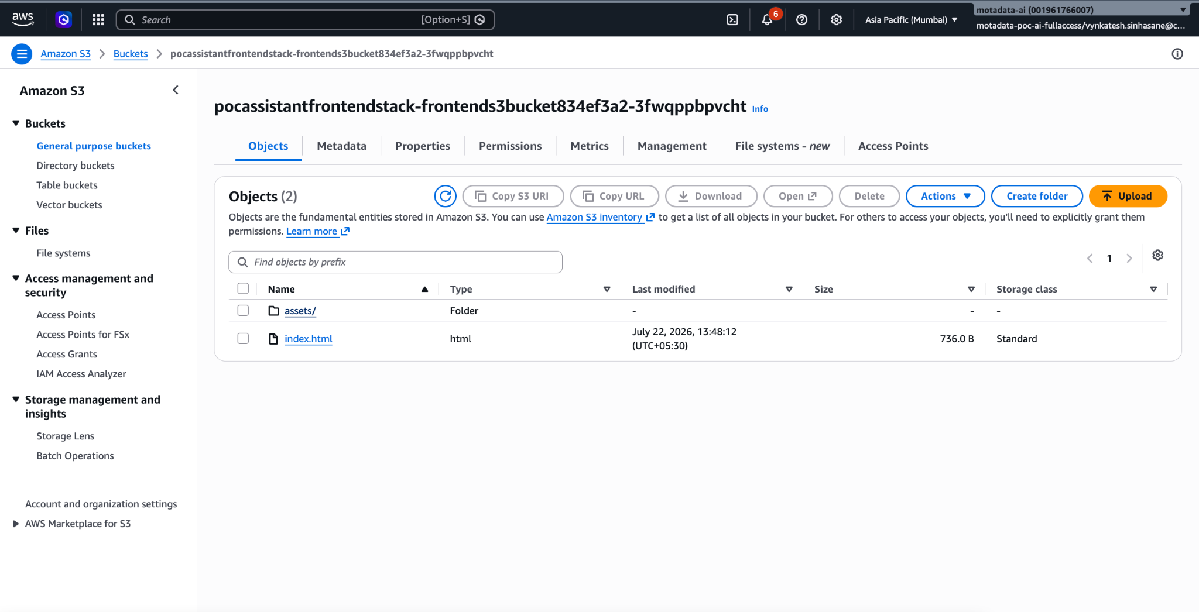

RDS PostgreSQL Setup
The RCA Investigator agent queries a PostgreSQL database containing OpenTelemetry-format telemetry data. The RDS instance rca-scenario-db runs PostgreSQL 16.14 on a db.t3.micro instance class with 20 GB gp3 storage in ap-south-1. The endpoint is rca-scenario-db.cng0ieo6guoi.ap-south-1.rds.amazonaws.com on port 5432. The instance is publicly accessible (POC configuration) with security group sg-056b27a95cb60d3a1 allowing inbound on port 5432 from 0.0.0.0/0.
Database credentials are stored in AWS Secrets Manager under the keys rca-db/default and rca-db/poc_account. The database contains three tables used for RCA investigation:
- Otel_metrics (12,120 rows per tenant) :
  - Time-series metrics including checkout_success_rate, dns_query_latency_p99_ms, kernel_rx_queue_latency_ms, payment_connection_acquire_ms, and irq_affinity_numa_mismatch. Each row contains tenant_id, ts (timestamp), metric_name, value, and labels (JSONB with dimensions like region, cluster, node_pool, pod).
- otel_logs (286 rows per tenant) :
  - Application and kernel logs from streams payment_service_logs, checkout_service_logs, kernel_logs, and infra_change_logs. Each row contains tenant_id, ts, stream, level, logger, message, and attributes (JSONB).
- otel_spans (840 rows per tenant) :
  - Distributed traces covering 84 complete request traces across 9 services (checkout, pricing, inventory, promotion, order, payment, token, fraud, payment-provider). Each row contains tenant_id, trace_id, span_id, parent_span_id, service_name, span_name, span_kind, start_time, end_time, duration_ms, and attributes (JSONB).
All tables include a tenant_id column and indexes on (tenant_id, metric_name, ts), (tenant_id, stream, ts), and (tenant_id, trace_id) for efficient tenant-scoped queries.

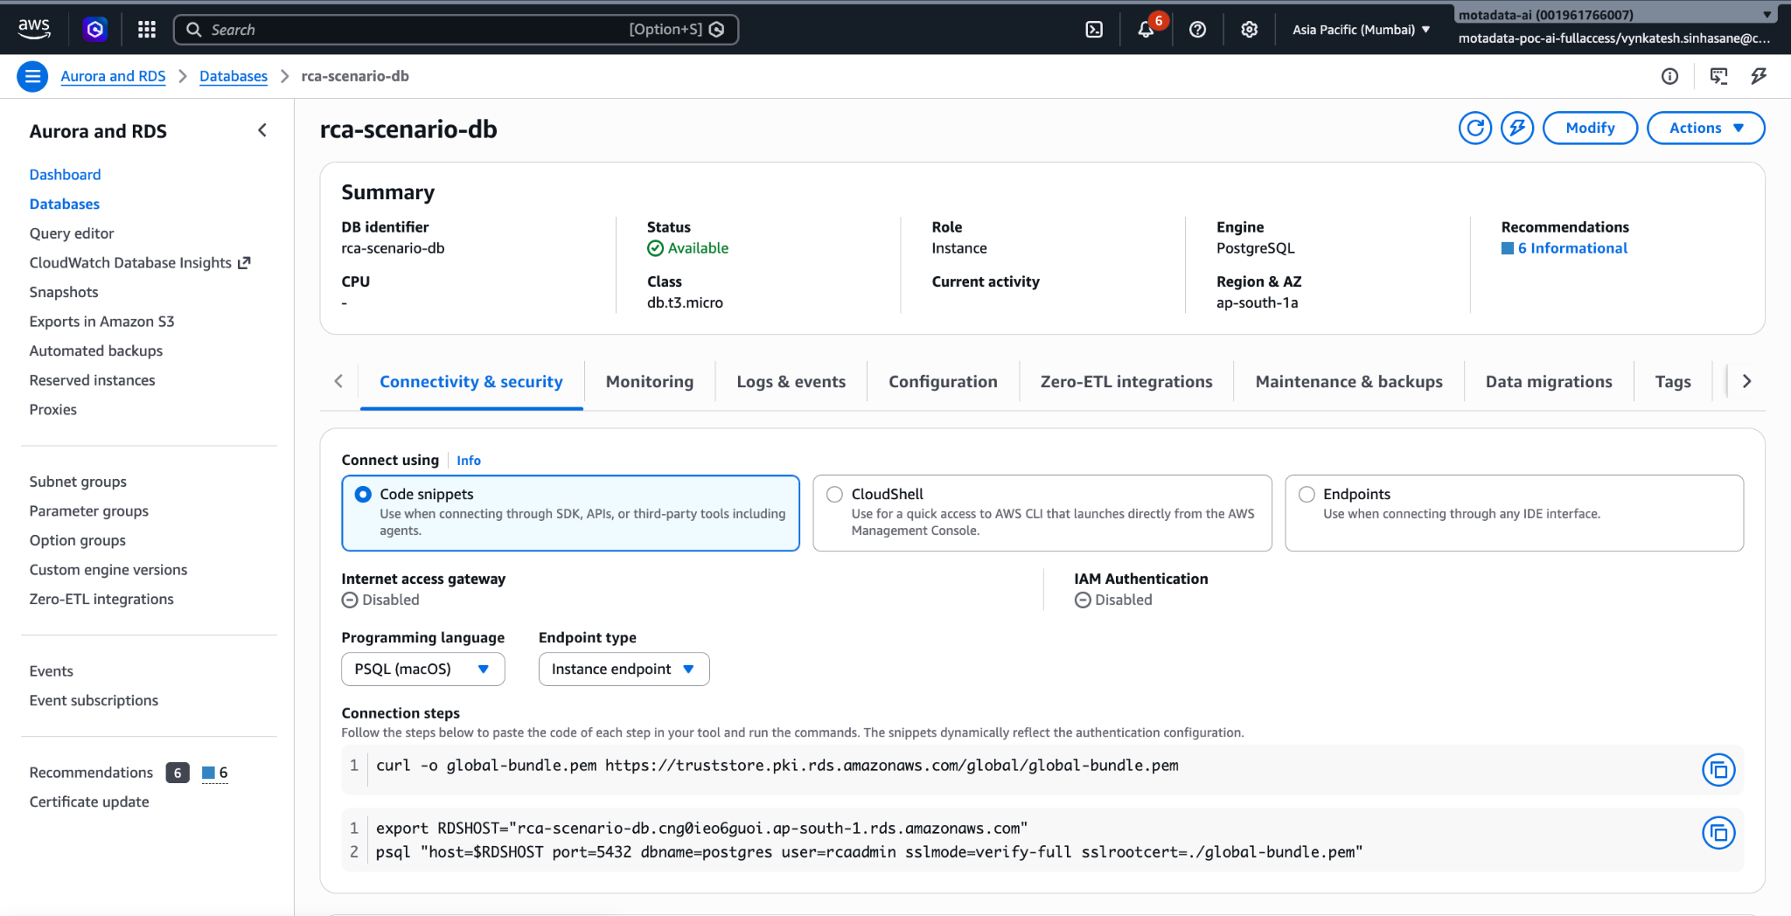

CloudFront and Cognito Setup
CloudFront
The application is served through Amazon CloudFront distribution E2KKBKVV0SMTV0 at https://d2e9bh1pq1a0sj.cloudfront.net. The distribution has two origins:
S3 Origin (default) :
Serves React frontend static assets with CachingOptimized policy. Custom error responses for 403/404 return /index.html with HTTP 200 to support SPA client-side routing.
ALB Origin (/api/*) :
Routes all API requests to the internal ALB with CachingDisabled policy (no caching on API responses) and AllViewerExceptHostHeader origin request policy. Read timeout is set to 60 seconds for streaming responses.
AWS WAF (poc-waf,ARN:arn:aws : wafv2:us-east-1:001961766007:global/webacl/poc-waf/e80736e1-d8d0-43a9-9ef3-8d623923d0bb) is attached to the distribution for SQL injection, XSS, and rate limiting protection.
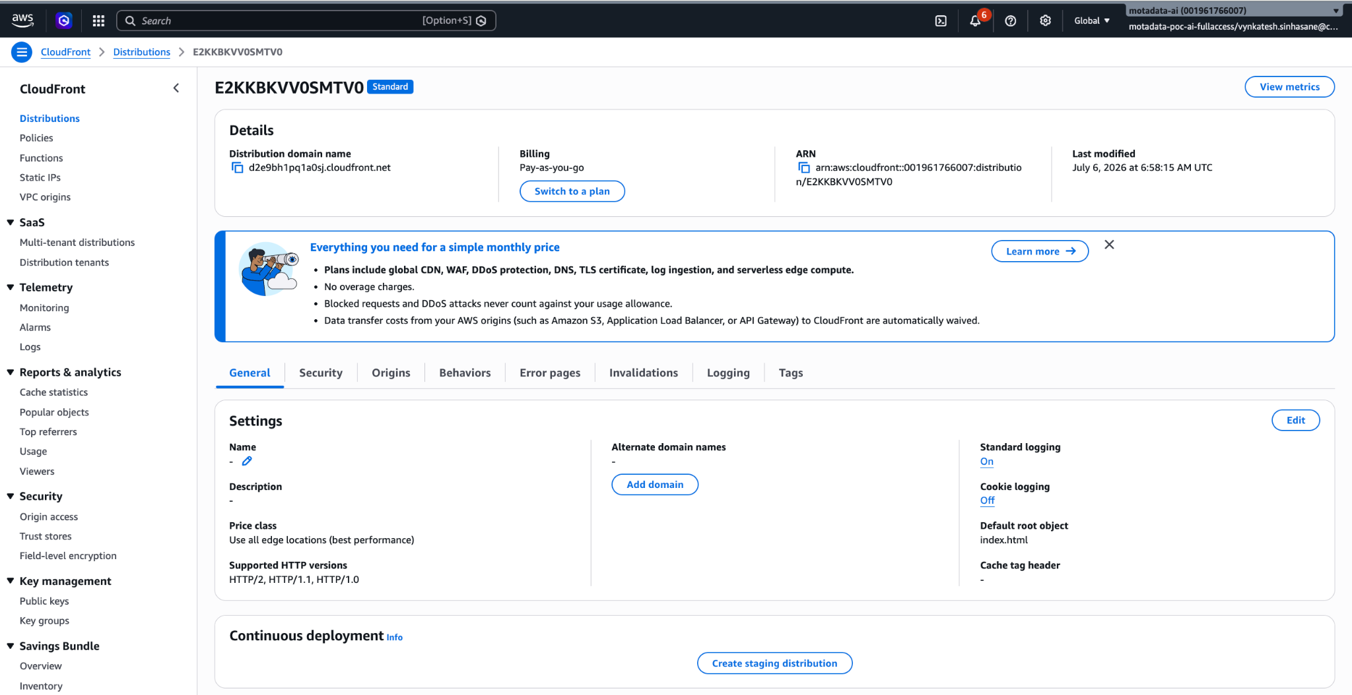
Cognito
Amazon Cognito User Pool ap-south-1_XoMze1ISf provides user authentication with web client ID 7bs3ae73cnblm9o44io7vg4tk3. Users authenticate via email/password and receive JWT tokens (1-hour access, 30-day refresh). The backend validates JWTs using the Cognito JWKS endpoint on every API request. The user's sub claim becomes the actorId for AgentCore Memory namespacing.
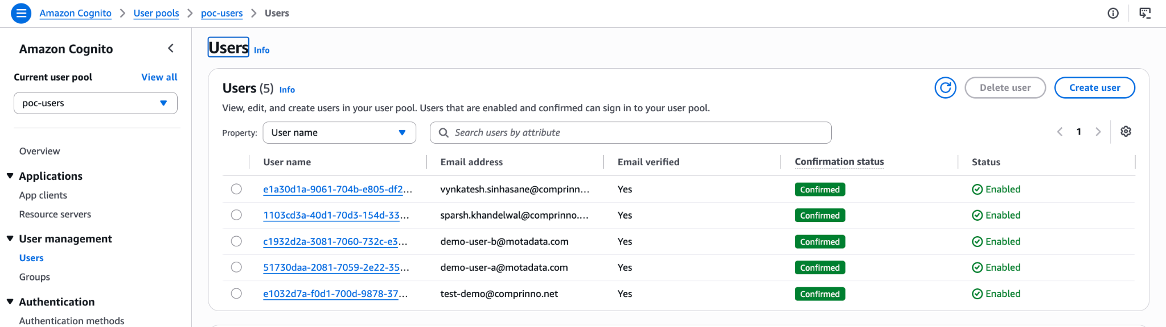

Code Change and Deployment Process
How to Make Code Changes and Redeploy — Backend
1. Make Code Changes
Navigate to the project root directory (which contains the backend/Dockerfile file):
cd /Applications/Comprinno/Client/Motadata/msp-ops-langgraph
Key Backend Files
- backend/app/main.py — FastAPI application entry point
- backend/app/api/routes.py — API endpoints (chat, accounts, health)
- backend/app/core/langgraph_client.py — Thin client for AgentCore invocation
- backend/app/core/workspace_context.py — Tenant credential management
- backend/app/core/telemetry.py — OpenTelemetry instrumentation
- backend/requirements.txt — Python dependencies
Make the required code changes and save the files.

2. Authenticate Docker with Amazon ECR
For macOS/Linux:
aws ecr get-login-password --region ap-south-1 --profile motadata | \
docker login --username AWS --password-stdin \
001961766007.dkr.ecr.ap-south-1.amazonaws.com

3. Build the Docker Image
docker build --platform linux/amd64 \
-t 001961766007.dkr.ecr.ap-south-1.amazonaws.com/poc-backend:latest \
-f backend/Dockerfile .
Note: The build context is the project root (not backend/) because the Dockerfile copies both the backend/ and agents/ directories.
4. Push the Image to Amazon ECR
docker push 001961766007.dkr.ecr.ap-south-1.amazonaws.com/poc-backend:latest
5. Update the ECS Service
aws ecs update-service \
--cluster poc-cluster \
--service poc-backend-service \
--force-new-deployment \
--region ap-south-1 \
--profile motadata
The deployment uses a rolling update strategy with a maximum of 200% and a minimum of 50% healthy tasks.
Monitor the deployment status:
aws ecs describe-services \
--cluster poc-cluster \
--services poc-backend-service \
--region ap-south-1 \
--profile motadata \
--query 'services[0].deployments[*].[status,runningCount,rolloutState]'
Wait until the PRIMARY deployment displays:
rolloutState: COMPLETED
and the previous deployment has been fully drained.
How to Make Code Changes and Redeploy — AgentCore Agents
1. Make Code Changes
Agent source code is located in the agents/ directory.
Agent Runtime Files
- agents/runtime/supervisor_runtime.py — Supervisor agent (routing and orchestration)
- agents/runtime_cloudwatch_langgraph/cloudwatch_a2a_runtime.py — CloudWatch specialist
- agents/runtime_security_langgraph/security_a2a_runtime.py — Security specialist
- agents/runtime_cost_langgraph/cost_a2a_runtime.py — Cost specialist
- agents/runtime_advisor_langgraph/advisor_a2a_runtime.py — Advisor specialist
- agents/runtime_jira_langgraph/jira_a2a_runtime.py — Jira specialist
- agents/runtime_knowledge_langgraph/knowledge_a2a_runtime.py — Knowledge specialist
- agents/runtime_investigator_langgraph/investigator_a2a_runtime.py — RCA Investigator
Each agent also contains:
- aws_tools.py — Local boto3 tool implementations
- gateway_client.py — MCP Gateway connectivity
Make the required changes and save the files.
2. Deploy the Agents
cd agentcore-deploy/motadatamsp
eval $(aws configure export-credentials --profile motadata --format env)
agentcore deploy --yes

This command:
- Builds container images for all modified agents.
- Pushes the images to Amazon ECR.
- Updates the AgentCore CDK stack.
The deployment typically completes in 3–5 minutes.
3. Force a Runtime Container Refresh
AgentCore may continue using cached container instances after deployment. To ensure the updated container image is used, update the runtime using the AWS CLI.
NEW_TAG=$(aws ecr describe-images \
--repository-name motadatamsp/<agent_name> \
--region ap-south-1 --profile motadata \
--query 'imageDetails | sort_by(@, &imagePushedAt) | [-1].imageTags[0]' \
--output text)
aws bedrock-agentcore-control update-agent-runtime \
--agent-runtime-id "<runtime_id>" \
--agent-runtime-artifact "{\"containerConfiguration\":{\"containerUri\":\"001961766007.dkr.ecr.ap-south-1.amazonaws.com/motadatamsp/<agent_name>:${NEW_TAG}\"}}" \
--role-arn "<role_arn>" \
--network-configuration '{"networkMode":"PUBLIC"}' \
--environment-variables '{"FORCE_RESTART":"'$(date +%s)'"}' \
--region ap-south-1 --profile motadata
Replace the following placeholders with the appropriate values:
- <agent_name>
- <runtime_id>
- <role_arn>
4. Verify the Deployment
agentcore invoke \
--runtime supervisor_langgraph \
--prompt "Hello" \
--json \
--timeout 60
How to Make Code Changes and Redeploy — Frontend
1. Make Code Changes
Frontend source code is located in the frontend/src/ directory.
Key Frontend Files
- pages/MainAppPage.tsx — Main chat interface
- pages/SignInPage.tsx — Login page
- components/ — UI components (NavigationPanel, MessageDisplay, ConversationHistory, etc.)
- store/chatStore.ts — Zustand state management
- services/api/apiClient.ts — Backend API client
Make the required changes and save the files.
2. Build the Frontend
cd frontend
npm run build

3. Deploy to Amazon S3
aws s3 sync dist/ \
s3://pocassistantfrontendstack-frontends3bucket834ef3a2-3fwqppbpvcht/ \
--delete \
--region ap-south-1 \
--profile motadata

4. Invalidate the CloudFront Cache
aws cloudfront create-invalidation \
--distribution-id E2KKBKVV0SMTV0 \
--paths "/*" \
--region us-east-1 \
--profile motadata
Allow approximately 30 seconds for the cache invalidation to propagate globally.

Tenant Account Management
Adding a New Tenant
The application supports multiple tenants. Each tenant's AWS account is accessed using STS AssumeRole with temporary credentials.
To add a new tenant:
- The tenant creates a cross-account IAM role with the ReadOnlyAccess policy and configures a trust relationship that allows AWS account 001961766007 to assume the role using an External ID.
- Add the tenant using the application's Add Account UI or create the secret manually:
aws secretsmanager create-secret \
--name "msp-credentials/<tenant_name>" \
--secret-string '{"account_id":"<id>","role_arn":"arn:aws:iam::<id>:role/<role>","external_id":"<ext_id>","customer_name":"<name>"}' \
--region ap-south-1 --profile motadata
- For RCA telemetry access, create the database secret and tag the RDS instance:
aws secretsmanager create-secret \
--name "rca-db/<tenant_name>" \
--secret-string '{"username":"rcaadmin","password":"...","dbname":"postgres","port":"5432"}' \
--region ap-south-1 --profile motadata
aws rds add-tags-to-resource \
--resource-name "<rds-arn>" \
--tags Key=tenant,Value=<tenant_name> Key=purpose,Value=rca-telemetry \
--region ap-south-1 --profile motadata
Credential Auto-Refresh
Tenant STS credentials expire after one hour.
The backend automatically refreshes credentials when they have expired or are within 10 minutes of expiration.
The frontend also performs an automatic refresh during page load by calling:
PUT /accounts/{name}/refresh
for any account displaying an Expired status.

Telemetry Data Management
Loading Demo Scenario Data
The RCA demonstration scenario (E-Commerce Checkout / Cross-NUMA IRQ Stall) is loaded using the dump_scenario_postgres.sh script.
This script generates OpenTelemetry-compatible telemetry data with timestamps relative to the current time, ensuring the anomaly always appears recent during demonstrations.
export PATH="/opt/homebrew/Cellar/libpq/18.4/bin:$PATH"
bash /Users/vynkatesh/Downloads/RCA-Scenario/dump_scenario_postgres.sh \
--host rca-scenario-db.cng0ieo6guoi.ap-south-1.rds.amazonaws.com \
--db postgres \
--user rcaadmin \
--password 'RcaP0c2026x' \
--tenants "poc_account" \
--truncate

Each tenant receives:
- 12,120 metric rows
- 286 log rows
- 840 span rows
covering a 60-minute time window.
To load data for multiple tenants:
--tenants "acme,globex,initech"

CloudWatch Logging and AWS X-Ray Tracing
All application containers running on Amazon ECS Fargate, along with all AgentCore runtimes, are integrated with Amazon CloudWatch Logs for centralized logging and monitoring.
ECS Backend Logs
The ECS task definition uses the awslogs log driver to stream container logs to the following CloudWatch log group:
POCAssistantBackendStack-TaskDefbackendLogGroup15A95F50-Y2cgwpa4Ibip
The log stream prefixes are:
- poc-backend/ — Backend application
- adot-collector/ — ADOT Collector
AgentCore Runtime Logs
Each AgentCore runtime writes logs to its own CloudWatch Log Group using the naming convention:
/aws/bedrock-agentcore/runtimes/{runtime_id}-DEFAULT
Log streams are created for each invocation session using the format:
[runtime-logs]{session-uuid}
AWS X-Ray Distributed Tracing
AWS X-Ray traces are collected using the ADOT sidecar container and are available in the CloudWatch X-Ray console.
Each chat request generates a distributed trace showing the complete request flow, including:
- API request latency
- Amazon Bedrock Runtime LLM calls
- DynamoDB operations
- AgentCore Memory interactions
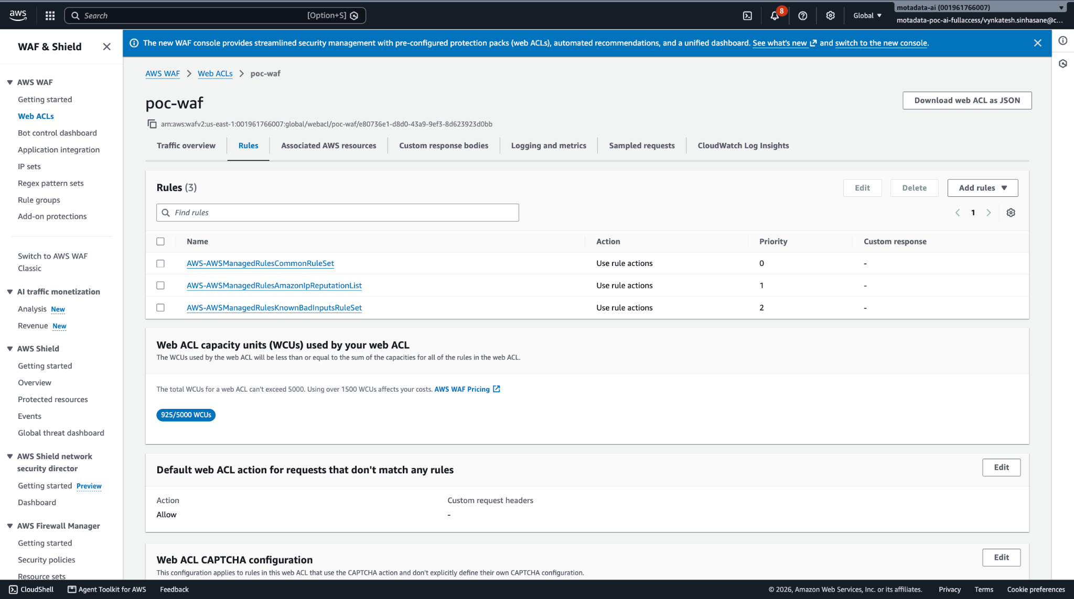
Accessing CloudWatch Logs
- Open the AWS Management Console.
- Navigate to CloudWatch (Region: ap-south-1).
- Select Logs → Log Groups.
- Open the appropriate log group.
- Use the following filter pattern to exclude health check requests:
-"GET /health"
or
-"GET /ping"
CloudWatch logs can be used to:
- Monitor the chat request and response lifecycle.
- Debug agent invocation failures and throttling.
- Track Bedrock model latency and token usage.
- Validate tenant credential propagation.
- Investigate timeout and error conditions.
- Monitor ECS deployment rollouts through task startup logs.

